Harrow Council
Annual Workforce Equality Report
2020-21

Contents

- Introduction
- About the data
- Definition of terms
- Staff completion of workforce data
- Age
  - Age and pay band
  - Age: Recruitment
- Disability
  - Disability and gender
  - Disability and pay band
  - Top 5% of earners with a disability
  - Disability: Recruitment
- Race (Ethnicity)
  - Race and sex
  - Race and pay band
  - Race, sex and pay band
  - Female and race
  - Male and race
  - Top 5% of earners from BAME communities
  - Race: Recruitment
  - Race: Turnover and leave
- Sex
  - Sex and pay band
  - Top 5% of earners that are women
  - Sex: Recruitment
- Religion and Belief
  - Religion and belief and pay band
  - Religion: Recruitment
- LGBTQIA+ (Gender reassignment and sexual Orientation)
  - LGBTQI+ and pay band
  - LGBTQI+: Recruitment
- Pregnancy and Maternity
  - Maternity and ethnicity
  - Maternity, ethnicity, and contract
  - Maternity and marital status
  - Maternity and age
  - Maternity and religion and belief
  - Maternity and LGBTQIA+

- Introduction

Harrow’s Workforce Equality Report covers the period between April 2020 to March 2021. This report contains a current snapshot of our workforce, broken down into each of the protected characteristics where data is held, which include:

- Age
- Disability
- Race (Ethnicity)
- Sex
- Religion and belief
- LGBTQIA+ (Gender reassignment and sexual orientation)
- Pregnancy and Maternity
- Marriage and Civil Partnership

As one of the most ethnically and religiously diverse boroughs in the country with many people from a vast range of diverse backgrounds living side by side, Harrow is committed to developing a workforce that is thriving, fair, diverse, and representative of the residents within our local community.

Over the last year, the council has demonstrated a renewed commitment to equality and diversity, through our work on race equality. This has seen the organisation embark on a new journey to become a fully accessible and inclusive employer, which welcomes a broad range of skills, experiences, and perspectives that are representative of Harrow’s vibrant community, and considers the rights of all staff.

This report provides an overview of the diversity profile of the council’s workforce and how this compares with the population of Harrow and the London average. The data in this report will help to inform the council’s workforce planning and decision-making processes in relation to levelling up the council’s offer for under-represented groups. The report will help shape the development of workforce initiatives to further improve the representation of minority groups within the Council, to ensure more inclusive processes and practices across the organisation.

- About the Data

Data sources:

Internal data used in this report has been drawn from:

- SAP ERP system as of 31 March 2021
- Staff completion of SAP data 2021
- Harrow Council Scorecard 2021
- Maternity returners 2018-19

Benchmarking data has been drawn from a range of sources including:

- The Human Capital Metrics Survey 2020 – 2021
- The Office of National Statistics
- The Greater London Authority
- The Government Equalities Office

Workforce information the report includes: The report relates to Harrow’s non-schools’ workforce. It excludes contracted services that are monitored by other sources.

The total number in Harrow’s Workforce as of 31st March 2021 is 2071.

Equality Data: Employees are able to choose whether or not to provide information on their equality characteristics, expect for certain information which is paramount for payroll processing and pension administration (e.g., age and gender). The data that follows is based on the number of employees that have chosen to provide their equalities information.

Percentage and Counts: Most figures are expressed as percentages but base counts (the number of employees that charts/graphs are based on) are provided in the report for reference. Please note that percentages in some cases have been rounded up to the nearest percentage point; meaning that figures presented may always sum up 100% exactly or other total presented.

Confidentiality: The local authority has done all the necessary checks to ensure that none of the information will lead to identification of an individual employee within Harrow’s workforce.

- Definition of Terms

BAME – BAME is used for the purposes of presenting data and does not replace the term ‘Black, Asian and Multi-ethnic’ as stated in the council’s Race Equality Action Plan.

Disability - Employees that have a disability or long-term impairment.

LGBT – Lesbian, Gay, Bisexual, Transexual.

Parenting responsibilities - Employees who have caring responsibilities for children or young people under the age of 18.

Promotions – Employees that have moved up one or more pay grade in the last 12 months.

Religion and Belief – A particular religion or philosophical belief an employee follows. This term also covers employees who have a non-formal religious or belief system.

Pay band – The pay band of employees working for Harrow Council. The pay bands used in the comparisons below are as follows:

Salary Lower Limit (£) | Pay Band | Equivalent to
0 | 1 | G1 - G3
21,967 | 2 | G4 - G8
33,877 | 3 | G9 - G11
46,384 | 4 | MG1 - MG3
66,940 | 5 | MG4 and D1
103,528 | 6 | D2 and above

4. Staff completion of workforce data

According to our most recent workforce profile date, Harrow council currently employs 2,071 full time and part time staff (this excludes school staff). Understanding the demographic make-up of our workforce relies on the completion of staff data on SAP.

Over the last four years, the completion of the council’s SAP data has been around 30% of our overall staff population, which although low, has gradually increased, from 27.2% in 2017/18 to 34.3% in Q1 of 2020/21.

Figure 1. Staff completion of SAP data, Harrow Council Scorecard

This increase could be attributed to incentives being put forward for employees to complete their data on SAP. The data used in this report is based on the number of staff who have provided information on their protected characteristics.

It is important to note that some data included in this report contains a higher rate of completion, including data on age, race, and sex.

5. Age

The graph below provides a summary of the age profile of our workforce, compared to the borough population. Most employees in Harrow’s workforce are between the ages of 35 to 64 (76.6%). The second largest demographic within our workforce is 25 to 34 age group at (13.8%), which is over-represented compared to our borough population.

However, compared with the Borough population, there is an under-representation of 16 to 24-year-olds in the workforce (1.6%) but an over-representation of those aged 55 to 64 and 45 to 54. In addition to this, 8% of employees fall in the age range of 65+, which is the highest across all London boroughs.

It is important to note that not all 16-24 year olds would be available for work, similarly, not all 65+ year olds would be available for work.

Figure 2. Age profile, SAP ERP, 31st March 2021

Over the last 4 years, the proportion of employees aged less than 25 years old has remained relatively the same.

Figure 3. Trend of employees aged less than 25, SAP ERP, 31st March 2021

The proportion of employees aged less than 25 in the council is lower than the London average, at 2.8%.

 | 2017/18 | 2018/19 | 2019/20 | 2020/21 | London
Proportion of employees aged less than 25 | 2.4% | 1.7% | 2.2% | 1.6% | 2.8%

5.1. Age and Pay band

The relationship between age and band of staff is illustrated in the graph below, which shows that staff between the ages of 16-24 tend to remain within pay bands 1-3. Representation at the higher pay bands of 4 and 5 is more visible in the 25-34 age group. Most staff in pay bands of 5-6 are aged 45-64. The vast majority of staff aged 65+ are between pay bands 1-3 with a small percentage at pay band 4.

Figure 3. Age and Pay band, SAP ERP, 31st March 2021

5.2. Age: Recruitment

In 2020-21, there were more applicants aged between 25 to 34 (25%) compared to those aged 35 to 44(19%), 45 to 54 (14%), 16 to 24 (12%) and 55 to 64 (7%). Around 22 % of candidates preferred not to mention their age group when applying for jobs. During the shortlisting process more candidates between the ages of 25 to 34 (27%) were shortlisted for jobs compared to their counterparts in the 35 to 44 (25%), 45 to 54 (25%), 55 to 64 (11%), 16 to 24 (8%) and 65 + (1%) age groups.

Figure 4. Applicant monitoring data March 2020 – April 2021

A small number of candidates (4%) preferred not to mention their age group during the shortlisting and appointment phases of the recruitment process. In 2020-21, there were more 25-34 year olds appointed to roles at 26%, however, this is very closely followed by staff aged 35 to 44 (25%) and 45 to 54 (24%). There were fewer 55 to 64 year olds appointed at 14%, with 16 – 24 years old and those aged 65+ were least successful.
6. Disability

The current proportion of our staff that have declared a disability is 4.3%, compared to 15.8% of the borough population.

Figure 5. Disability data, SAP ERP, 31st March 2021

While staff sharing disability status remains low, with 36.5% of the workforce choosing either ‘prefer not to say’ or ‘unknown,’ this is an increase from previous years, which saw around 2% of the workforce declaring a disability.

Figure 6. Percentage of employees declaring a disability, SAP ERP, 31st March 2021

Although 4.2% of our workforce sharing a disability is an improvement from previous years, this still remains low compared to the London average:

 | 2017/18 | 2018/19 | 2019/20 | 2020/21 | London
Percentage of employees declaring a disability | 2.0% | 1.9% | 1.9% | 4.2% | 5.47%

6.1. Disability and gender

According to our data most employees declaring a disability within our workforce are female (66%) with the other (33%) being male. However, it is important to note that this analysis is based on 4.2% of the workforce that have declared a disability.

Figure 7. Disability and gender, SAP ERP, 31st March 2021

6.2. Disability and pay band

The majority of staff who declared a disability are in pay bands 5 and 6 (22.6%) compared to 2.5% in pay band 4. 12.8% of staff who declared a disability are in pay bands 1-3.

Figure 8. Disability and pay band, SAP ERP, 31st March 2021

6.3. Top 5% of earners with a disability

 | 2017/18 | 2018/19 | 2019/20 | 2020/21 (Q1) | London
The percentage of the top 5% of earners in the authority with a disability | 3.9% | 4.7% | 5.1% | 4.9% | 4.25%

The percentage of top 5% earners in our workforce with a disability, increased every year between 2017/18 – 2019/20 at 0.8 % and 0.4 % respectively. However, during 2020/21 the number of disabled employees in the top 5% of earners at Harrow has decreased 0.2%. This is still greater compared to the London average.

Figure 8. Percentage of top 5% earners with a disability, Scorecard, 31st March 2021

6.4. Disability: Recruitment

Figure 9. Applicant monitoring data March 2020 – April 2021

In 2020-21, the majority of applicants that applied for roles did not disclose a disability (96%) compared to those with a disability (2%). In addition, 1% of applicants preferred not to say whether they had a disability or not. At the shortlisting stage most of the shortlisted candidates did not disclose a disability (96%) compared to those that had a disability (2%) or preferred not to say (2%). During the appointment stage a large number of staff that were appointed to roles did not have a disability compared to those that disclosed a disability (5%) and staff that preferred to not say (1%).
7. Race (Ethnicity)

For the purposes of this report, the ethnicity profile in Harrow has been shown in terms of BAME and white groups as follows:

Figure 10. Ethnic groups, SAP ERP, 31st March 2021

White staff are over-represented in the workforce (43.8%) compared to our borough population (around 36%). Whereas staff from BAME communities are under-represented in the workforce, with 46.4% of the workforce, compared to around 65% of the borough population.

Over the past four years, the proportion of BAME staff in the council has remained relatively consistent, with a small increase between 2019-2021.

Figure 11. Percentage of BAME staff, Scorecard, 31st March 2021

BAME staff in the council are slightly better represented compared to the rest of London:
 | 2017/18 | 2018/19 | 2019/20 | 2020/21 | London
BAME | 46.0% | 46.9% | 48.2% | 48.4% | 46%

7.1. Race and sex

The graph below gives a breakdown of our workforce according to race and sex. Over 55% of our male workforce is white. By contrast, 50% of our female workforce are from BAME communities, with the largest proportion coming from an Asian background (35%), compared to 42% of our female workforce that is white. NB: the ethnicity of 8% of staff is unknown.

Figure 12. Ethnicity and gender, SAP ERP, 31st March 2021

7.2. Race and pay band

Our current pay band data also shows that compared to borough demographics we currently have a higher representation of white staff in the council. White staff are generally well represented across all pay band. However, there is an under-representation of BAME staff in all pay bands in the council. Asian staff are significantly under-represented across all pay bands, and our Black staff are only slightly better represented in some areas.

Figure 13. Ethnicity and pay band, SAP ERP, 31st March 2021

7.3. Race, sex and pay band

A further breakdown of ethnicity pay band data by gender gives a more detailed picture of where ethnic groups are concentrated according to gender. The following two sections gives an analysis of pay band according to ethnicity and female and male staff in the workforce.

7.4. Female and race

A breakdown of our ethnicity profile by gender and pay band shows that white women are over-represented in the upper pay bands and BAME women are overrepresented in lower pay bands.

66% of women in pay band 5 and 6 is are white female staff compared to 28% female staff from BAME communities. A breakdown of pay band 4 shows that 54% of female staff are white, compared to 36% of female staff from a BAME background by contrast, pay bands 1 and 2 have an over-representation of female staff from BAME communities (53%) compared to 38% of white, female staff.

Figure 14. Ethnicity, gender and pay band, Female, SAP ERP, 31st March 2021

7.5. Male and race

Similarly, pay band 5 and 6 is disproportionality over-represented by white male staff (76%), compared to 16% male staff from BAME communities. However, pay bands 1 and 2 also have an over-representation of white male staff (52%), compared to 39% of male staff from BAME communities. 61% of our staff in pay band 3 and 4 are white male, compared to 32% of male staff from a BAME background.

Figure 15. Ethnicity, gender and pay band, Male, SAP ERP, 31st March 2021

7.6. Top 5% of earners from BAME communities

The percentage of top 5% earners in our workforce from BAME communities in 2020/21, has stayed relatively the same at 25.5%.

Figure 16. Percentage of top 5% earners from BAME communities, Scorecard, 31st March 2021

The percentage of top 5% of earners in our workforce from BAME communities is greater than the London average, however Harrow's percentage of top 5% earners who are from black and minority ethnic groups of 25.5% falls in the fourth quartile of all the London boroughs, and for outer London

 | 2017/18 | 2018/19 | 2019/20 | 2020/21 (Q1) | London
Percentage of top 5% earners from BAME communities | 25.5% | 27.1% | 25.3% | 25.5% | 19%

7.7. Race: Recruitment

According to our recruitment data for 2020-2021, around 69% of applicants were from BAME groups and 28% of applicants were white. At the shortlisting stage 22% of BAME candidates were shortlisted for roles, compared with a figure of 25% for white candidates. Finally, BAME candidates received 28% of all job offers compared to a figure of 40% for white candidates.

Figure 17. Applicant monitoring data March 2020 – April 2021

In 2020-21, white applicants were more likely to be successful from application, to shortlisting and appointment stage compared to BAME applicants, as detailed below.
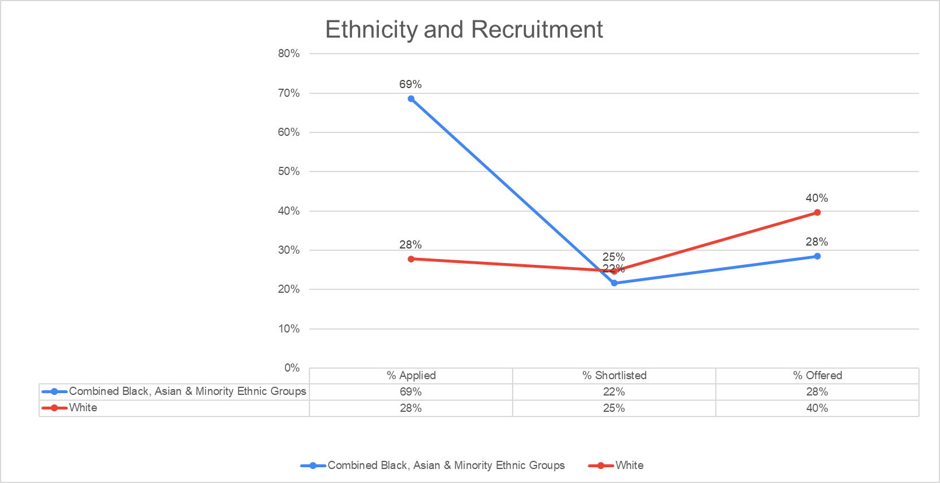
Figure 18. Applicant monitoring data March 2020 – April 2021

7.8. Race: Turnover and Leave

Figure 19. Ethnicity, turnover data, SAP ERP, 31st March 2021

Our data demonstrates that 52% of BAME staff left the organisation in 2020-21 compared with 48% of White Staff. In addition, Harrow Council has a higher percentage of turnover from BAME staff (12%) in comparison to White Staff (11%). Around 36% of turnover data was submitted by staff who did not disclose their ethnicity. However, this does not affect the observations that can be made from the data available. In 2020-21, 59% of white staff resigned, compared to their BAME counterparts (41%). Finally, the rate of dismissals (which includes redundancies) was at the same rate (50%) for BAME and White staff.

8. Sex

Female staff are over-represented in the workforce (62%) compared to our borough population (around 50%). Whereas, male staff are under-represented in the workforce, with 39% of the workforce being male, compared to around 50% of the borough population.

Figure 20. Gender profile, SAP ERP, 31st March 2021

In terms of our workforce profile, our staff base is overwhelmingly female:

Figure 21. Gender profile, SAP ERP, 31st March 2021
Although women are fairly represented across the organisation, representation at senior pay bands remains low. Despite 61% of our workforce being female, only 53% of our top 5% of earners are women and men make up 64.3% of our highest pay band

8.2 Sex and pay band

Figure 22. Gender and pay band data, SAP ERP, 31st March 2021

8.2 Top 5% of earners that are women

The percentage of top 5% earners that are women, stayed relatively the same over the past four years (53.9%). Harrow's percentage of top 5% earners who are female falls in the third quartile of all the London boroughs and for outer London. Between 2019/20 - 2020/21 the number of women in the top 5% of earners at Harrow has increased by 1.4%.

Figure 23. Trend of Top 5% of earners that are women, SAP ERP, 31st March 2021

The percentage of women in the top 5% is greater than the London average.

 | 2017/18 | 2018/19 | 2019/20 | 2020/21) | London
Percentage of top 5% earners that are women | 52.0% | 55.1% | 52.5% | 53.9% | 50%

8.3 Sex: Recruitment

Figure 24. Applicant monitoring data March 2020 – April 2021

In 2020-21, there was a higher rate of applications from women (60%) compared to men (40%). At the shortlisting stage more females were shortlisted for jobs (60%) than their male counterparts (39%). In addition, around 1% of shortlisted applicants preferred not to mention their gender when reaching this stage of the recruitment process. Around 65% of shortlisted female applicants were appointed to roles within the council compared to 35% for their male equivalents.

9. Religion and belief

Religion and belief are massively underreported in the council, with over 50% unknown. In 2020-21, 23% of our workforce declared Christianity as their religion, compared to 8.9% no religion/ atheist, 7.6% Hinduism, 4.5% Islam and 2.7% other. These top three religions are under-represented in the council, compared to our borough population.

Figure 25. Religion profile, SAP ERP, 31st March 2021

9.1. Religion and belief and pay band

Across pay bands 1-6, the majority of staff did not declare their religion in 2020-21. However, from the figures we have available it can be determined that staff who identify as Christian faith are the most represented in pay bands 1-6, followed by No Religion/Atheist, Hinduism and Islam in pay bands 1-4.

However, at pay band 5 staff that follow Judaism is the third most represented group and are followed by Islam. Beyond pay band 5 only staff that are Christian, No/Religion Atheists or have not recorded their religious belief are represented.

Figure 26. Gender and pay band data, SAP ERP, 31st March 2021

9.2. Religion and belief: Recruitment

According to our data staff who followed Christianity (40%), Islam (17%), Hinduism (16%) or Atheist/No Religion (12%) were most likely to apply for jobs. Other faiths that applicants followed included Sikhism (2%), Other (2%), and Buddhism (1%). Around 9% of this data was submitted by applicants that preferred not to disclose their religious belief.

Figure 27. Applicant monitoring data March 2020 – April 2021

At the shortlisting stage 44% of staff that followed the Christian faith were shortlisted for jobs compared to Islam (15%), Hinduism (14%), Atheist/No Religion (14%), Prefer not to say (10%), Sikhism (1%), Buddhism (1%), Judaism (1%) and Other (1%).

Finally, at the appointment stage more staff that followed Christianity were appointed for roles (45%) in comparison with staff that were Atheist/No Religion (15%), Hinduism (13%), Islam (12%), and Prefer not to say (10).

10. LGBTQIA+ (Gender Identity and sexual orientation)

Staff reporting on LGBTQIA+ (sexual orientation and gender identity) is underreported with around 1% of our workforce declared themselves as LGBTQIA+. None of our staff reported gender reassignment.

Figure 28. Sexual orientation and gender identity profile, SAP ERP, 31st March 2021

10.1. LGBTQIA+ and pay band

The sexual orientation and gender identity of our staff was largely ‘unknown’ across all pay bands in 2020-2021, which is fairly represented across all pay bands. There is a similar picture for staff declaring themselves as heterosexual. The greatest proportion of staff declaring themselves as LGBTQIA+, was in pay band 5 (2.8%), and pay band 3 (1.8%).

Figure 29. Sexual orientation, gender identity and pay band data, SAP ERP, 31st March 2021

10.2. LGBTQIA+: Recruitment

At the application, shortlisting and appointment phases of the recruitment process almost all candidates were Heterosexual straight 89%, 91% and 89% respectively in contrast to 6% for Bisexual and Gay/Lesbian (at all stages of the recruitment process). Candidates that preferred not to state their sexual orientation remained consistent at 6%, 6% and 9% correspondingly.

Figure 30. Applicant monitoring data March 2020 – April 2021
11. Pregnancy and Maternity

The maternity data that has been analysed below is from 2018-19.

In 2018-2019 most female staff that returned from maternity leave stayed for a period beyond 4 months (78%). A smaller percentage of female staff left within 4 months of returning from maternity leave (9%). Finally, just under a quarter of female staff (14%) did not return to work at all after taking maternity leave.

Figure 31. Maternity returners 2018-19

11.1. Maternity and ethnicity

In 2018-19 more female white staff (51%) returned to work and stay beyond 4 months after taking maternity leave, in comparison with their BAME counterparts (41%). Around 8% of this data was submitted by women that did not share their ethnicity. However, this does not affect the analysis that can be made from the data available.

In addition, for the same period, both BAME and white female staff left Harrow within four months of returning from maternity leave at the same rate (50%).

Finally, more white women did not return to work after taking maternity leave (54 %), compared to a 31% figure for BAME women and 15 % figure for women that did not share their ethnicity.

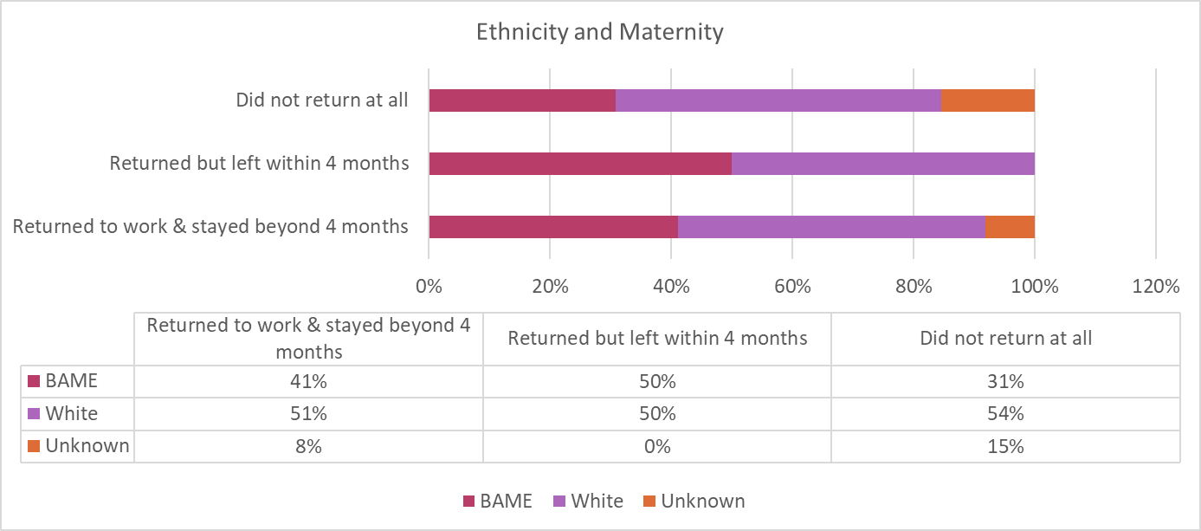
Figure 32. Maternity returners 2018-19

11.2. Maternity: Ethnicity and Contract

The graph below shows the relationship between ethnicity, female staff returning from maternity leave, and their employment contracts.

In 2018-19, white female staff with full time (FT) (18%) and part time (PT) (33%) contracts stayed in work beyond four months, when returning from maternity leave compared to their BAME counterparts (FT 14% and PT 27%).

Figure 33. Maternity returners 2018-19

Similarly, most female full-time (FT) staff who left between 2018-19 within 4 months of returning from maternity leave were BAME (25%) compared with a figure of 13% of white female staff. However, white female staff on part time contracts, were most likely to leave Harrow within four months of returning from maternity leave (38%) compared with a figure of 25% for their BAME counterparts. Lastly, female staff most likely to not return at all from maternity leave from white backgrounds were 23% for FT staff and 31% for PT staff compared to 8% and 23% for BAME groups respectively.

The two tables below provide a summary of the link between ethnicity and the reasons why female staff left the organisation after returning from maternity leave.

11.3. Maternity and Marital Status

In 2018-2019 more married women returned from maternity leave and stayed for a period beyond four months (30%), in comparison with their single counterparts (16%). In addition, 53% of this data was collected from female staff that did not disclose their marital status. According to our data single and married women left Harrow within 4 months of returning leave at the same rate (25%). Moreover, 50% of the data concerning female staff that left within four months of returning from maternity leave, was submitted by women that did not disclose their marital status. Finally, 23% of female staff that did not return from maternity leave were single with the other 77% of female staff not disclosing their marital status.

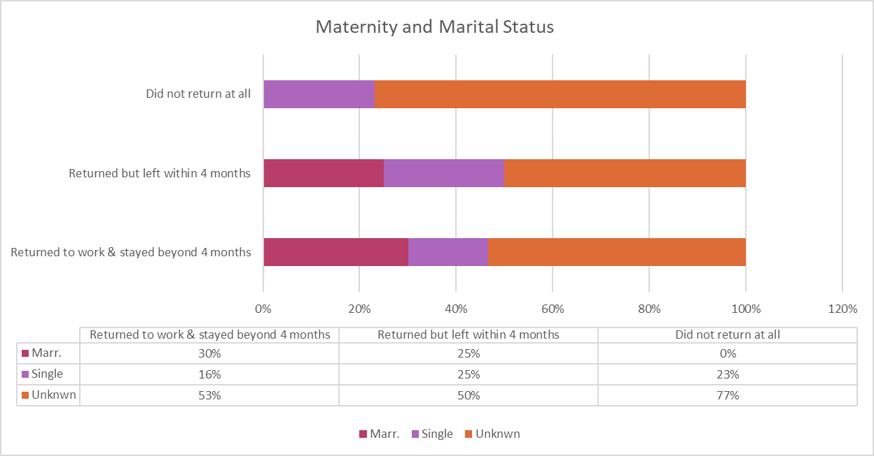
Figure 34. Maternity returners March 2020 – April 2021

11.4. Maternity and Age

In 2018 – 2019 female staff aged 35 to 44 (49%) were more likely to return from maternity leave and stay beyond four months compared to their counterparts in the 25 to 34 (48%), 16 to 24 (1%) and 45 to 54 (1%) age groups. Most women that left within 4 months of returning from maternity leave were aged 25 to 34 (50%), with smaller numbers of the 35 to 44 (38%) and 45 to 54 (13%) demographics leaving the organisation within the same period. Most female staff that did not return at all from maternity leave were aged 25 to 34 (62%) with a smaller number of the 35 to 44 (38%) also not returning to Harrow.

Figure 35. Maternity returners 2018-19

11.5. Maternity and Religion and belief

As mentioned throughout the report religion remains massively underreported within Harrow Council. Based on the data we hold, the majority of female staff from all religious backgrounds have returned from maternity leave and stayed beyond four months.

Figure 36. Maternity returners 2018-19

11.6. Maternity and LGBTQIA+

Sexual orientation also remains massively underreported within Harrow Council. The vast majority of female staff that declared themselves to be heterosexual returned to work and stayed beyond four months. But the majority of staff information in this regard is unknown.

Figure 37. Maternity returners 2018-19

